V24640

This instrument is an experimental balance, incomplete and unfinished. Many of the parts in the drawer do not belong to this, and many essential parts are clearly missing. As far as we can tell, this is intended to be an unusual form of hydrostatic balance, for determining the density of solids or liquids. I will give a brief account of how those conclusions were reached; much more could be said.

First, we need to decide who "J. Newman, 122 Regent Street, London" was, and when. He was John Newman, 1783-5th July 1860. After his apprenticeship he traded as an independent instrument-maker from 1807 onwards, at several addresses. He worked at 122 Regent Street from c.1826 (there is a slight uncertainty, 1825-1828) until December 1859, when the business was closed. He established a reputation for fine scientific instruments, and was particularly noted for his barometers. He was also - and this is crucial for the interpretation of V24640 - the resident instrument-maker at the Royal Institution (RI), from 1809 onwards. His son John Frederick Newman, 1830-1900, was involved in the business in its later years and up to its closure. It is important to note the massive confusion in the literature between JN and JFN, with many sources naming them as JFN senior and JFN junior. This confusion was eventually resolved in Bull. SIS in 1996-7. [1] See also [2] for a general biography of John Newman.

As far as I can tell, on a very brief survey, Newman made very few balances, and the two which I have found are very simple and nothing like this. One of these two was a hydrostatic balance but of a very simple and mostly conventional design. [3] One feature is that the pillar was sleeved, with one cylinder sliding outside another, as a part of the arrestment system. That looks to be the intention with V24640, but what we can currently see makes no mechanical sense. His simple hydrostatic balance was made in his previous workshop, so we know that Newman knew how to create a hydrostatic balance when he started on V24640. In this earlier balance there is a simple sensitivity adjustment screwed into the apex of the beam, but, most surprisingly, there is a second, similar but longer item present, loose, looking very much like the pointer cum sensitivity adjuster in a Robinson balance. Let's call this a 'pointer' for now. They appear to be two interchangeable sensitivity adjusters, for two different kinds of work perhaps, meaning normal weighing and hydrostatic weighing. I think this is relevant to V24640, but I'm no expert on hydrostatic weighing and cannot take this line of thought further.

V24640 has a most unusual beam. It is a two-knife beam rather than the conventional equal-arm three-knife laboratory balance beam. The beam has a graduated extension, marked with eleven vertical lines, giving ten intervals. Clearly this extension is intended to act as a rider bar, rather in the manner of a Mohr balance, and should be enumerated 0, 1, 2....8, 9, 10. The numbers are missing, suggesting that it is unfinished. Note that the tip has been fashioned to be a crude pointer, as in his earlier balance, which had a graduated scale erected behind it on a bracket. With the main knife of this beam resting on the little clear agate square planes at the top of the stand, the 'rider bar' will be swinging between the two brass extension bars on the Right. But there is no sign of any screw holes from which a graduated scale for the crude pointer could be mounted, nor any locating notches; nothing - again suggesting unfinished.

The superficial resemblance of the balance to those of T.C. Robinson (1792-1841) has already been noted. This is mainly due to the wide oval cut out in the pillar, which has become known as the "Robinson Tulip." A short pointer cum sensitivity adjustment hangs from the lower edge of a Robinson beam, and moves over a very short graduated scale mounted within the "Tulip." (See photos TCR1 and TCR4 sent 4/5/21.)
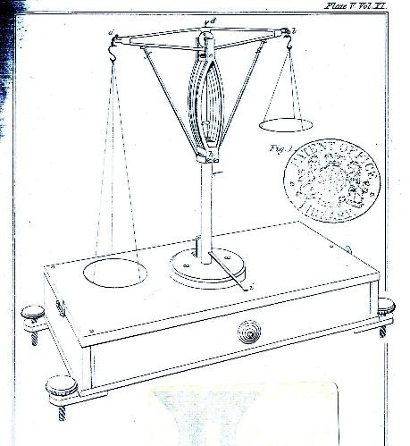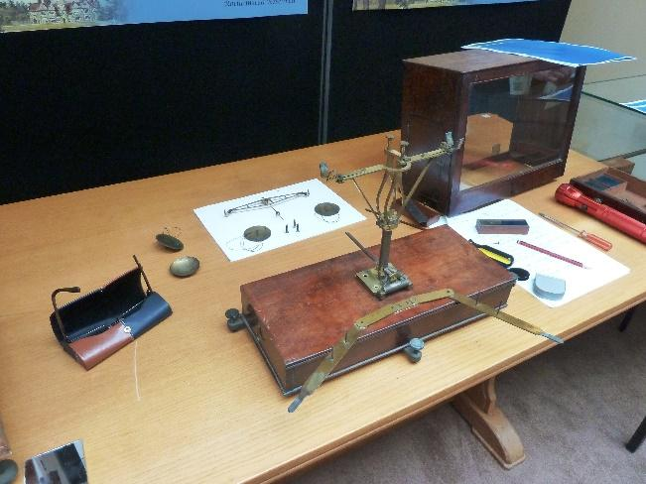
TCR1 TCR4

In this Newman example, there is no sign of any screw holes for such a scale, again suggesting unfinished. Nor is there any such scale in the contents of the drawer, again missing or unfinished.

The beam has a tiny hole on the lower edge. The 'pointer'
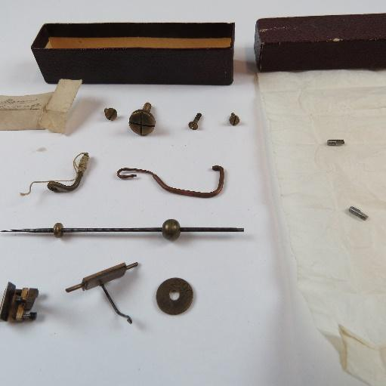
(second item up in your photo h2) would screw in here, and seems to be of the correct length to match a short scale mounted in the Robinson manner. But there is also a hole at the apex of the beam, where the 'pointer' could be fitted as an upwards pointer, yet again there are no signs of screw holes for the erection of a graduated scale behind the pointer. This suggests it is in fact solely a sensitivity adjustment, and not a pointer at all, hence the absence of a short scale within the Tulip. Therefore the crudely shaped tip of the 'rider bar' is the pointer for this balance, even though no scale has yet been erected for it. Is Newman trying ideas out, or possibly creating a multipurpose instrument, or has he not finished it? This is all very confusing, and suggests experimental, incomplete and unfinished.

Of the three pans, the one on the left has a tiny stud in the centre, indicative of a small hook on the underside from which to suspend items for hydrostatic weighing. Most hydrostatic balances have three pans, such that they could also be used for normal weighing with two normal pans. But there is no third knife here; therefore it was intended only as a hydrostatic balance - in which case why three pans? The small j-hook suspension piece (middle item, bottom row in photo h2) is the correct size for the end knife, but seems too small to fit between the two V-shapes in the supports on the Left cross pieces.

We have been completely unable to understand the apparatus on the engraved base of the stand, and it would need to be removed to examine the mechanism beneath. It looks superficially to be an arrestment device, working with the sleeving, but currently it makes no mechanical sense to us. Most obviously, there is nothing present at the head of the stand to hold the beam when arrested, strongly suggesting unfinished. The top face of the wooden case is in such excellent condition that it means the instrument was never used, suggesting abandoned.

No normal, commercial instrument-maker could possibly have afforded time to create an object like this, unfinished and unsold. But Newman was the instrument-maker to the RI, where he was creating instruments for several researchers. He is recorded as making various instruments "of ingenious and imaginative design, and of first rate quality." I propose that V24640 is one of his specials for the RI, unfinished and abandoned because the researcher lost interest, or left, or died, or he and Newman realised they had come to an over-engineered dead end. It is therefore impossible to date this item with any certainty, other than c.1826 at the earliest, and could be any date up to 1859. But, Robinson up to 1841, and Oertling from 1846 onwards, showed simpler and better ways of devising hydrostatic balances. Therefore I propose that it dates most probably from c.1826 to c.1841, and definitely not as late as anywhere near c.1860, by which time Oertling was the top balance-maker in England, leading the way in design.

In conclusion, it appears to be an experimental, incomplete, unfinished and abandoned attempt by John Newman at a hydrostatic balance, dating from c.1826 to c.1841. I feel I can go no further.

References.

[1] Bulletin of the Scientific Society 50 (1996), 11-14; 51 (1996), 22-25; 53 (1997), 14.
[2] https://doi.org/10.1093/ref:odnb/39365
[3] In the Museum of the History of Science, Oxford, inventory no. 324.

Barry J. Oliver.
31 mei 2021

